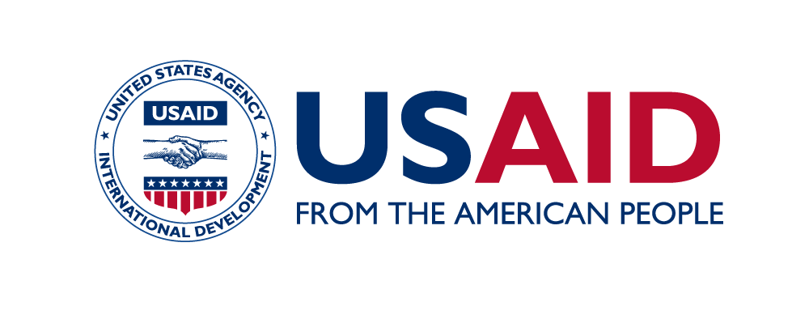

Workshop on

“Functional and Institutional Analysis of Public Institutions, Organizational Structure”

A G E N D A

20 April 2018
Tbilisi, Georgia
Venue: Holiday Inn Tbilisi
9:30 – 10:00 | Registration of Participants
10:00 – 10:30 | Opening Remarks  - CATHERINE KARDAVA, Head of the Civil Service Bureau of Georgia  - SOPHIE HUET GUERRICHE, Sector Coordinator for Governance and Human Capital, Delegation of the European Union  - LAURA BERGER, Georgia Democracy, Governance and Social Development Office Director, USAID
10:30 – 11:00 | Group Picture and Coffee Break
PANEL I. FUNCTIONAL/INSTITUTIONAL ANALYSIS OF PUBLIC INSTITUTIONS; ORGANIZATIONAL STRUCTURE – EXPERIENCE OF EaP COUNTRIES
11:00 – 13:00 | Moderator: CATHERINE KARDAVA, Head of the Civil Service Bureau of Georgia  - Introduction to Functional Reviews  SALTANAT LIEBERT, Associate Professor L. Douglas Wilder School of Government & Public Affairs Virginia Commonwealth University  - Pilot Project on Functional Review of Two Ministries  DAVIT HARUTYUNYAN, Public Administration Reform Team Leader, Center for Strategic Initiatives, Armenia  - Recent Developments in Public Administration: Experience of Azerbaijan MAHAMMADALI KHUDAVERDIYEV, Head of Division of the State Agency for Public Service and Social Innovations under the President, Azerbaijan  - Institutional and Functional Analysis of Public Institutions in Rural Areas and Small Towns in Belarus  ALEKSANDR BAICHOROV, Professor at Belarus State University, Belarus  - Central Public Administration Reform in Moldova  LILIA CAZAC, Senior Adviser of Public Administration Division of the State Chancellery, Moldova  - Functional Analysis of Public Institutions in the Framework of the Public Administration Reform  KYRYLO YURCHENKO, Senior Consultant of SIGMA and CIB Coordination Division, Projects Management Unit of the Center for Adaptation of the Civil Service to the Standards of the European Union, Ukraine  - The Role of CS Institutions in the Reforming Public institutions and Strengthening Governance  GUBAD IBADOGHLU, Eastern Partnership Civil Society Forum  Questions and Answers
13:00 – 14:00 | Lunch
PANEL II. IMPLEMENTATION OF PRINCIPLES OF EFFECTIVE GOVERNANCE: GEORGIAN EXPERIENCE AND LESSONS LEARNED
14:00 – 15:45 | Moderator: MAIA DVALISHVILI, Deputy Head of the Civil Service Bureau of Georgia  - Policy Planning and Evaluation: Georgian Case  NINA SARISHVILI, Head of Policy Analysis, Strategic Planning and Coordination Department, Administration of the Government of Georgia  - Importance of Public Internal Financial Control Reform  IRMA GELANTIA-AKHVLEDIANI, Deputy Head, Public Internal Control Department Central Harmonization Unit, Ministry of Finance of Georgia  - Insights of Functional and Institutional Analyses in Georgia  IRINA AGHAPISHVILI, Head of Analytical Department, Civil Service Bureau of Georgia  - Lessons Learned on Functional Reviews: Georgian Perspective  PAPUNA TOLIASHVILI, Founder of Synergy Group and Current Managing Director, Synergy Group  - Lessons Learned on Functional Reviews  ANSI SHUNDI, Freelance Expert on Public Administration Reform  Questions and Answers
15:45 – 16:15 | CATHERINE KARDAVA, Head of the Civil Service Bureau of Georgia  Conclusions & Follow-up Recommendations  Closing Remarks & Coffee Break
16:30 – 17:00 | Transfer to Tech Park (Innovation Str. 7, 0114 Tbilisi, Georgia)
17:00 – 18:00 | Tech Park Tour
18:00 – 18:30 | Transfer to Dinner Venue
18:30 – 22:00 | Dinner

